**STEP BY STEP PROCEDURE TO CREATE A FEDORA VIRTUAL MACHINE IN ORACLE VM VIRTUALBOX MANAGER**

# Step 1:

Open Oracle VM VirtualBox Manager and click on *“New”*

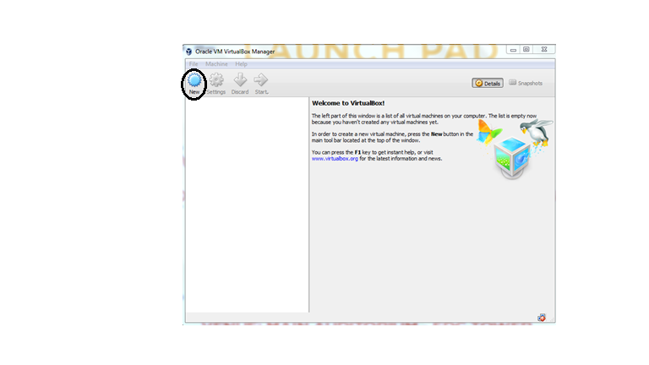

# Step 2:

Type a name for your Virtual Machine, select type as Linux, Version as Fedora and click Next.

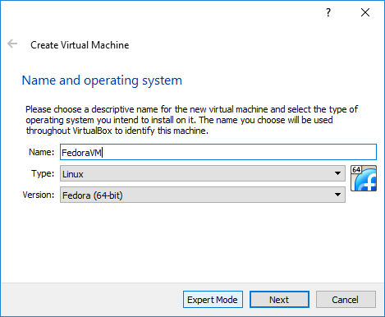

# Step 3:

Allot some Memory RAM. 1 GB is recommended.

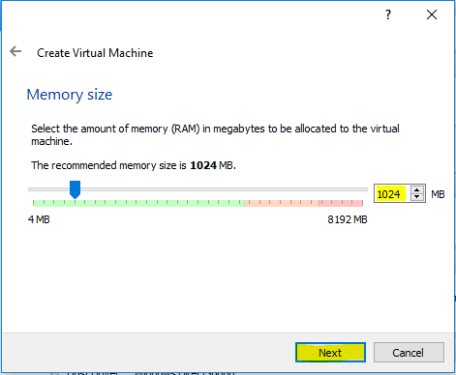

# Step 4:

Choose to create a new virtual hard disk or not, or you can also use an existing one. Create a virtual hard disk for your VM and click “Create”.

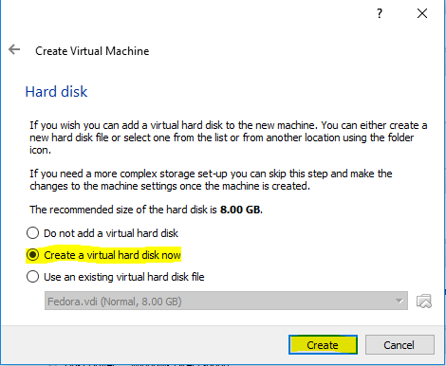

# Step 5:

Select the medium. Choose *VDI (Virtual Disk Image)* and click “Next”

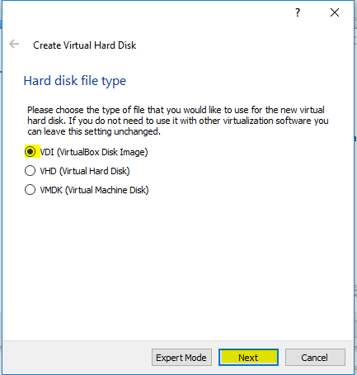

# Step 6:

Select Dynamically Allocated and click “Next”.

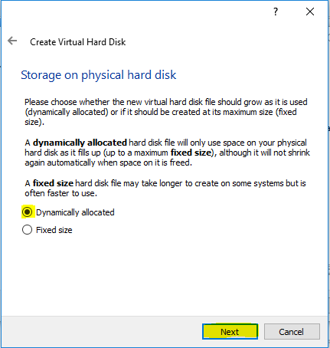

# Step 7:

Select the size of the virtual hard disk in MBs. 8 GB is recommended.

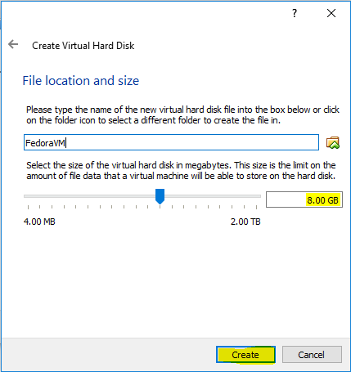

# Step 8:

Now, You’d see a VM created on the left side of the window. Select the VM and click on settings.

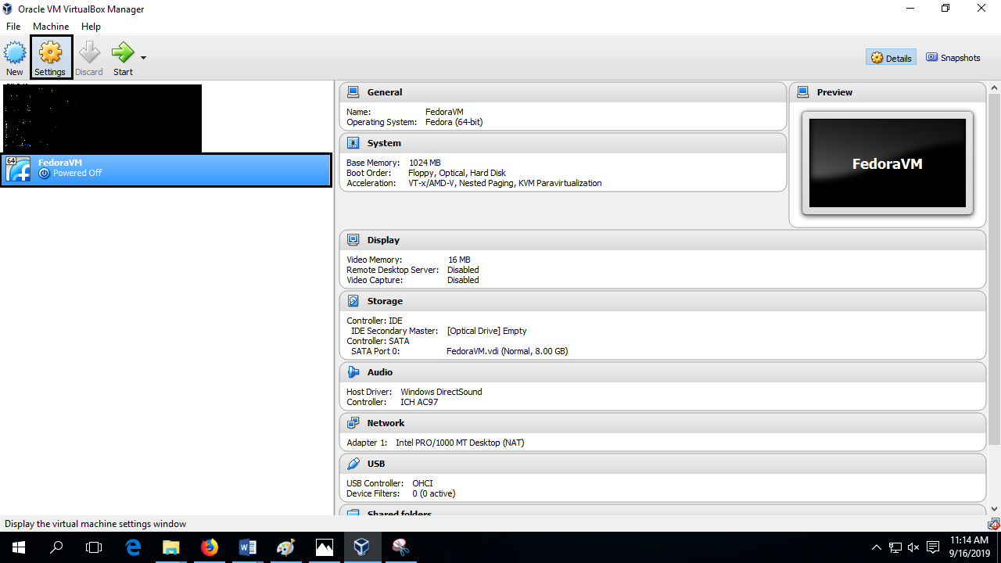

# Step 9:

Click on storage then on empty and click the cd icon on the right of the window.

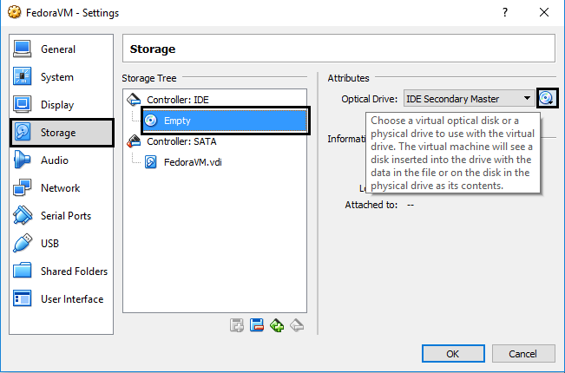

# Step 10:

Browse and select the already copied ISO file of Fedora, and click Open.

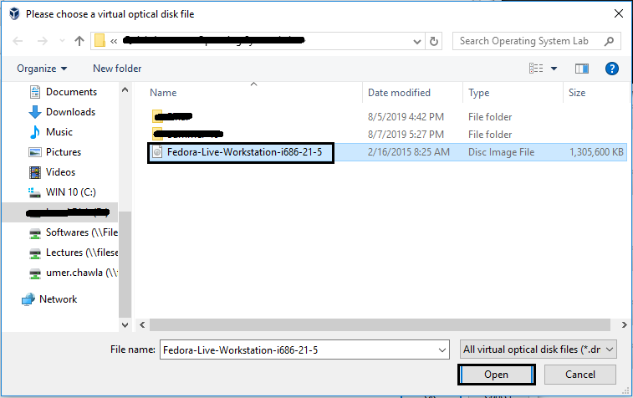

# Step 11:

Now You would be able to see chosen file under controller, click OK.

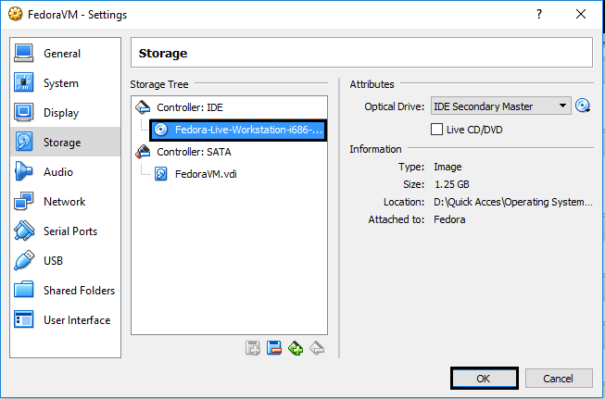

# Step 12:

Select the VM you created and press start.

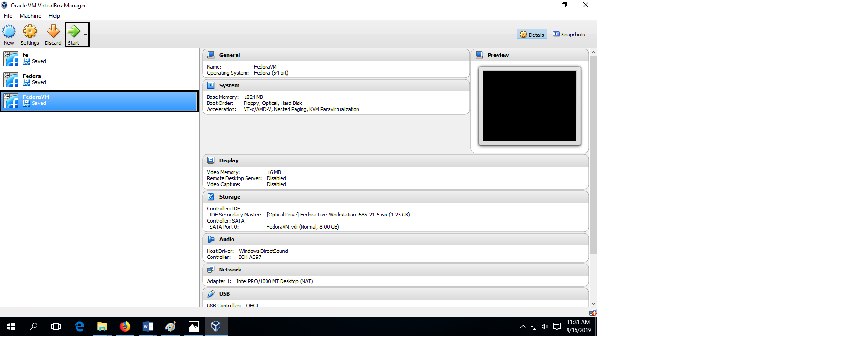

# Step 13:

After few seconds “*Welcome to Fedora*” Screen will appear. Just Click on “*Try Fedora”* and Close.

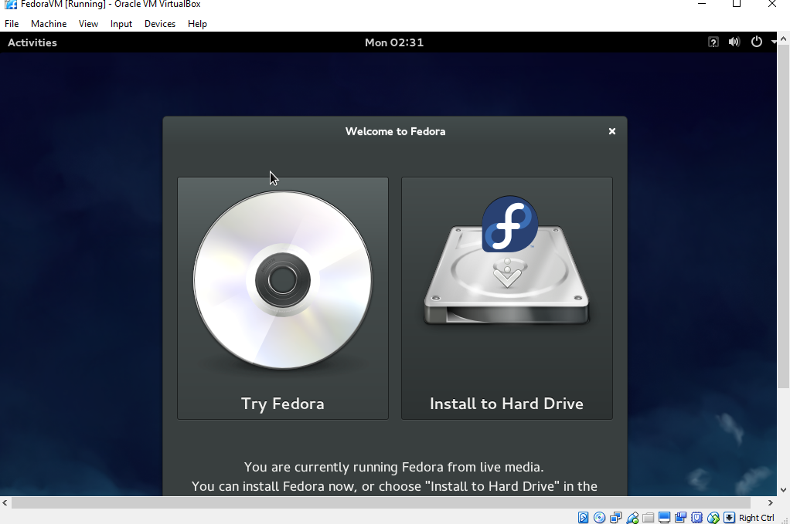

# Step 14:

Fedora Desktop would appear and ready to use.

